**ASSIGNMENT 5 – FOOD BLOG WITH SAGA**

**Steps :**

1. Create app foodblogsaga and install required packages

ubuntu@ip-172-31-25-178:~$ cd foodblogsaga

ubuntu@ip-172-31-25-178:~/ foodblogsaga$ npm i axios json-server redux-promise react-router-dom react-slick redux redux-devtools-extension redux-saga

ubuntu@ip-172-31-25-178:~/ foodblogsaga$ sudo npm install json-server

ubuntu@ip-172-31-25-178:~/ foodblogsaga/src/components$ json-server --watch food_blog.json --port 5000

ubuntu@ip-172-31-25-178:~/ foodblogsaga/ $ npm start

**Code :**

https://github.com/hemapunniakotti/ReactProjects/Assignement5_FoodblogSaga

**Output :**

1. The food blog has list of food items. Have added the CSS to make sure it looks like tiles

Figure

1. On clicking the link the details of the food is displayed

1. Below page captures user enquiries

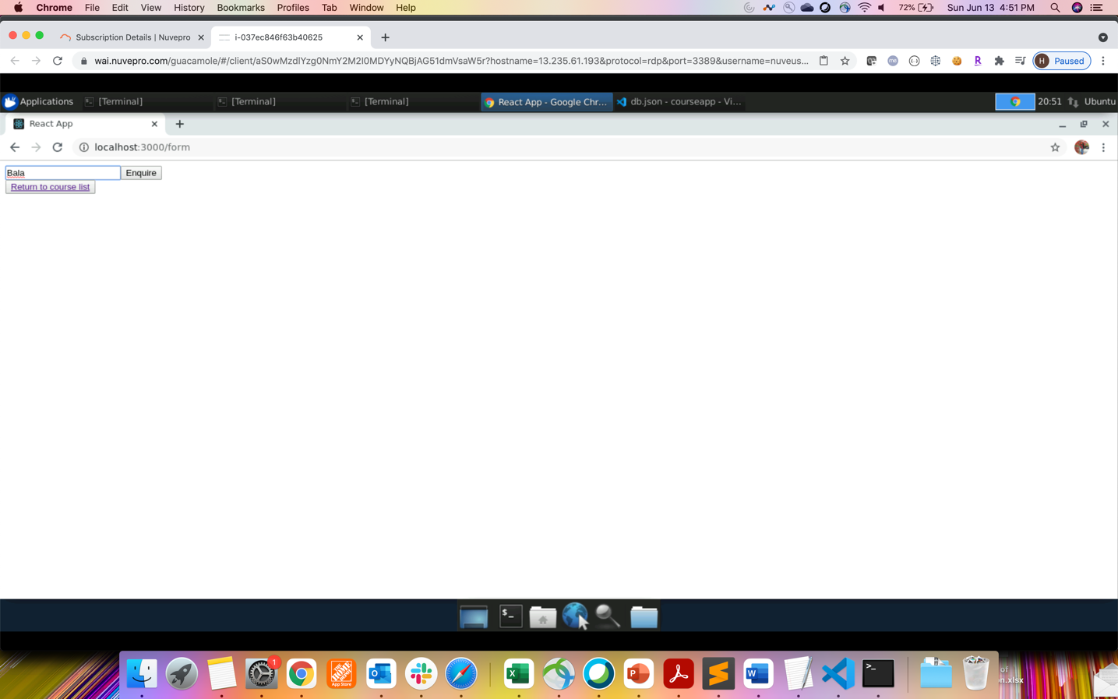

1. The enquiries is listed from the db.json which gets updated after user makes an enquiry.

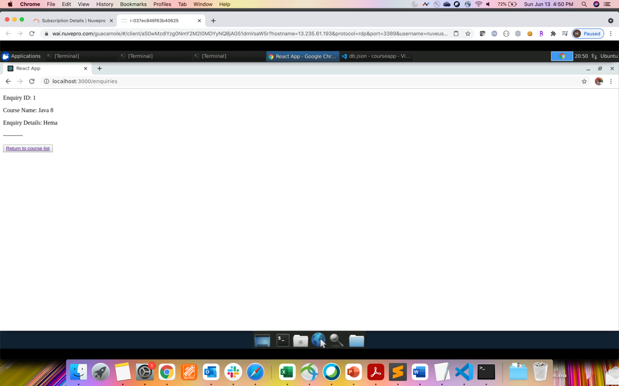

1. After user makes second entry –

1. Data gets updated in the db.json file –

